Compute The linear regression problem step by step:

Step 1: Dataset
We are given:
x: 1, 2, 3, 4
y: 2, 4, 6, 8
So the dataset is:
((1,2), (2,4), (3,6), (4,8))

Step 2: Formula for Linear Regression
The regression line is:
[ y = mx + c ]
Where:
- (m) = slope
- (c) = intercept
Formulas:
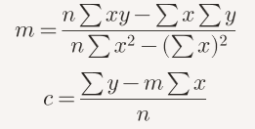
Step 3: Compute Summations
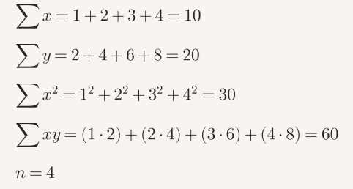
Step 4: Compute Slope (m)
m = {4(60) - (10)(20)} / {4(30) - (10)^2}
m = {240 - 200} / {120 - 100} = {40} / {20} = 2

Step 5: Compute Intercept (c)
c = 20 - (2) * (10) / {4}
c = 20 – 20 / 4 = 0

Step 6: Regression Equation
y = 2x + 0 => y = 2x

Step 7: Prediction for (x = 5)
y = 2* (5) = 10

Final Answer:
- Regression equation: y = 2x
- Predicted value when x = 5 ; y = 10

Problem 2
Dataset: x:2,4,6,8; y:5,7,9,11
Equation: y=0.75x+3.5
Prediction for x=10: y=11
Problem 3
Dataset: x:1,3,5,7; y:2,6,10,14
Equation: y=2x
Prediction for x=9: y=18
Problem 4
Dataset: x:10,20,30,40; y:15,25,35,45
Equation: y=x+5
Prediction for x=50: y=55
Problem 5
Dataset: x:1,2,3,4; y:3,6,9,12
Equation: y=3x
Prediction for x=5: y=15
Problem 6
Dataset: x:5,10,15,20; y:7,14,21,28
Equation: y=1.4x
Prediction for x=25: y=35

